MINI PROJECT
TOPIC

AI Usage and Impact on Students & Professionals

SRUTHI S

INTRODUCTION
Dataset focuses on understanding how people use Artificial Intelligence tools in their education, work, and daily activities. The dataset includes both students and professionals, allowing us to compare their AI usage patterns and understand how AI affects different groups of users. It contains demographic information such as age, gender, country, education level, and profession, along with information about income and the type of user

DATASET
https://docs.google.com/spreadsheets/d/1_hZyKOT2G_C_IYEv4zGfZlcld2NDqnUK/edit?usp=drive_link&ouid=115896051230921480257&rtpof=true&sd=true

IMPORT DATA
- Raw data is converted to Table Structure
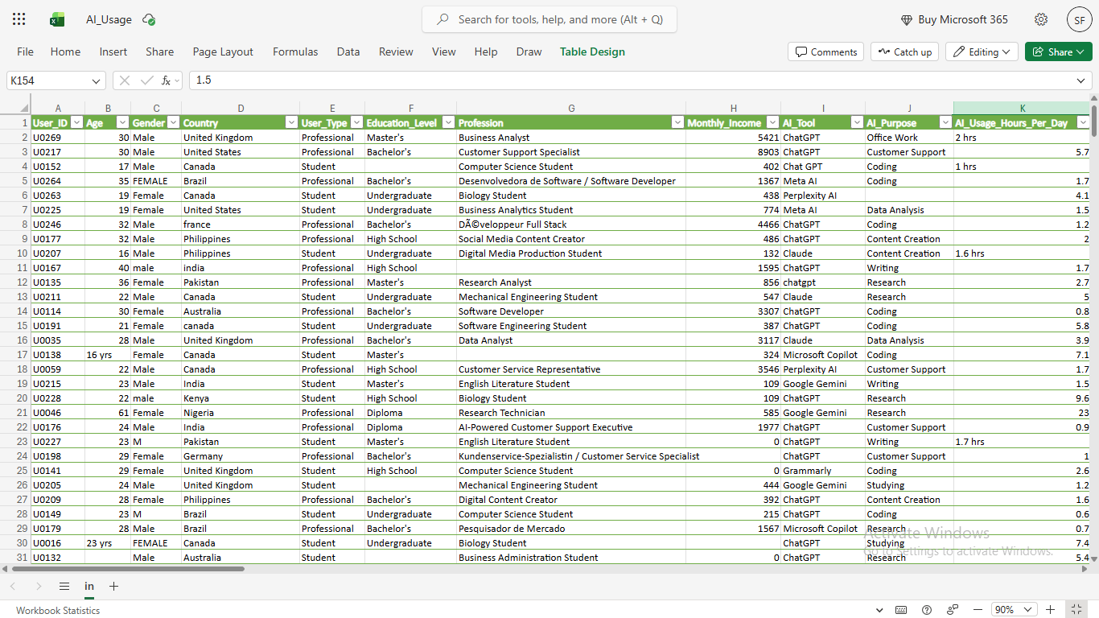

DATA CLEANING
User_ID
Remove Duplicates By User_ID
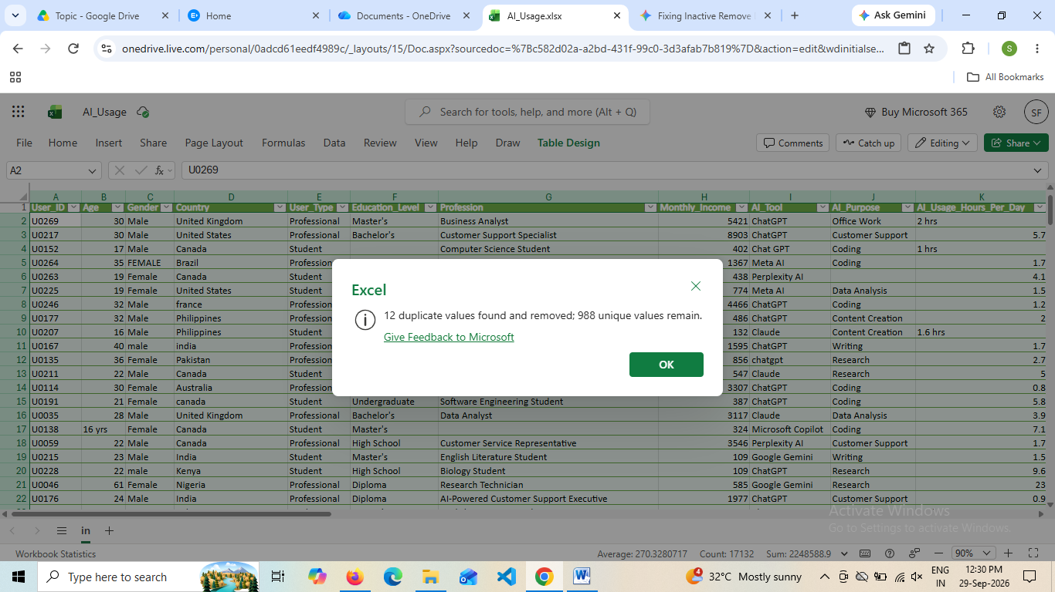
Age
- Age Field Contain an Inconsistency
Eg:16yrs
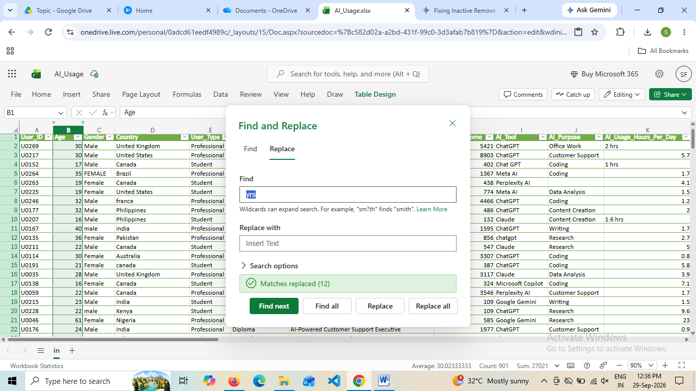

- Age Field contain blank cells these are rectified by using descriptive statistics such a mean finally got the resulting value 30
Use ISBLANK ,Create New Column Age imputed
- Age Datatype is Converted to Number

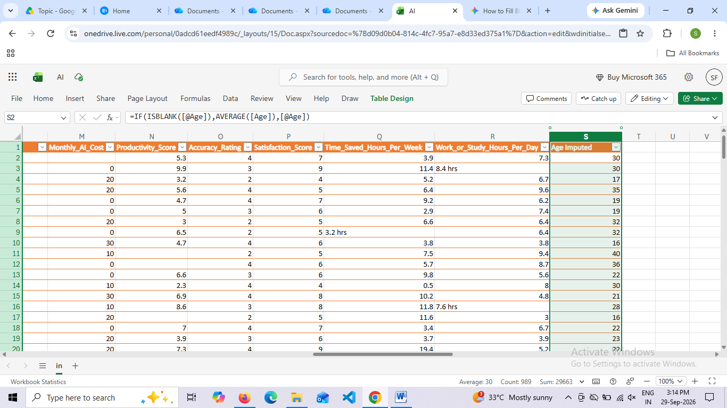

Gender
- Gender Column Contain Typo error
- FEMALE--Female
- M---Male
- F----Female
- Male-Male
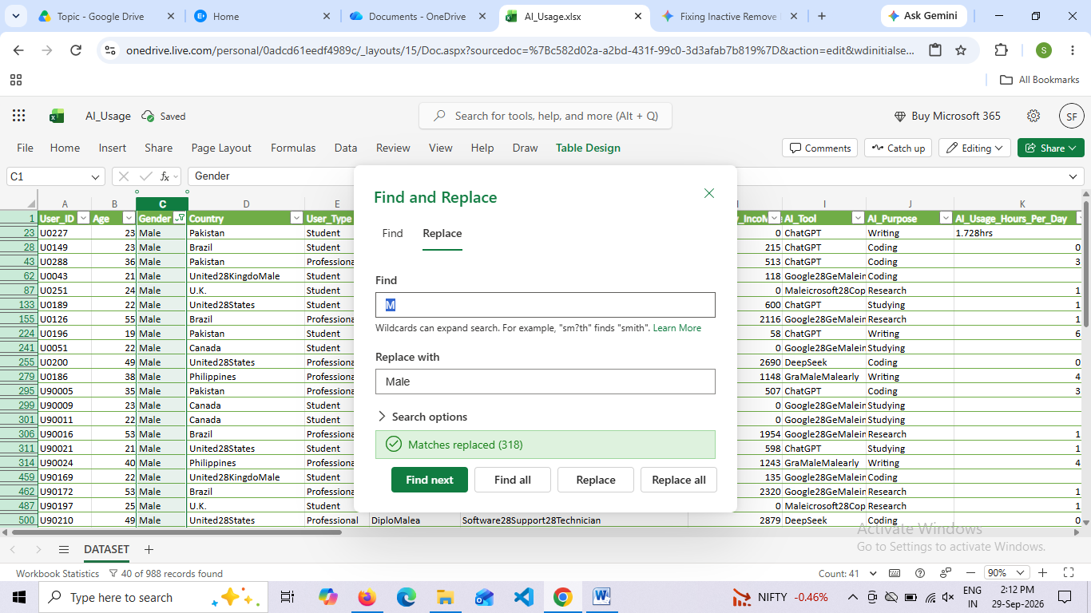

Country
- Country Contain Missing Values Replace By using Unknown
- Proper function is used Standarzed
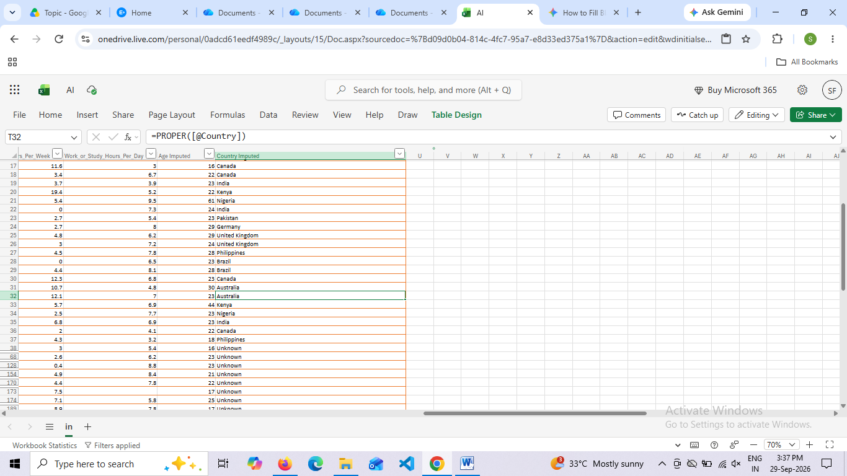

EDUCATIONAL LEVEL
- Educational level missing values use unknown to impute
- Typo errors corrected
- Bachelors….> Bachelor’s
- master's degree---Master’s
- HS--High School
- Ph.D……….>phD
- Undergadu-Undergraduate

- 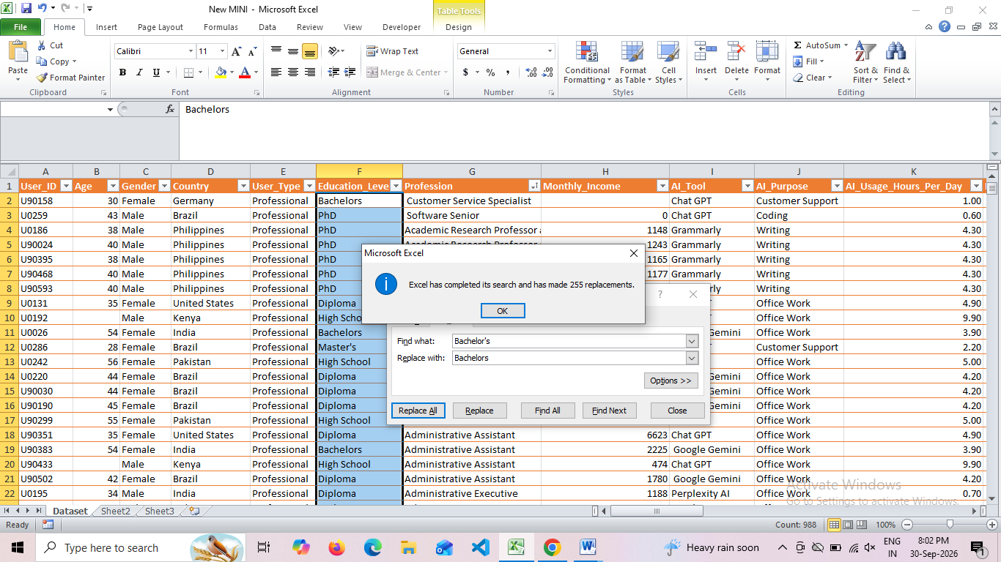

Profession
Typo error
SÃªnior replaced to Senior

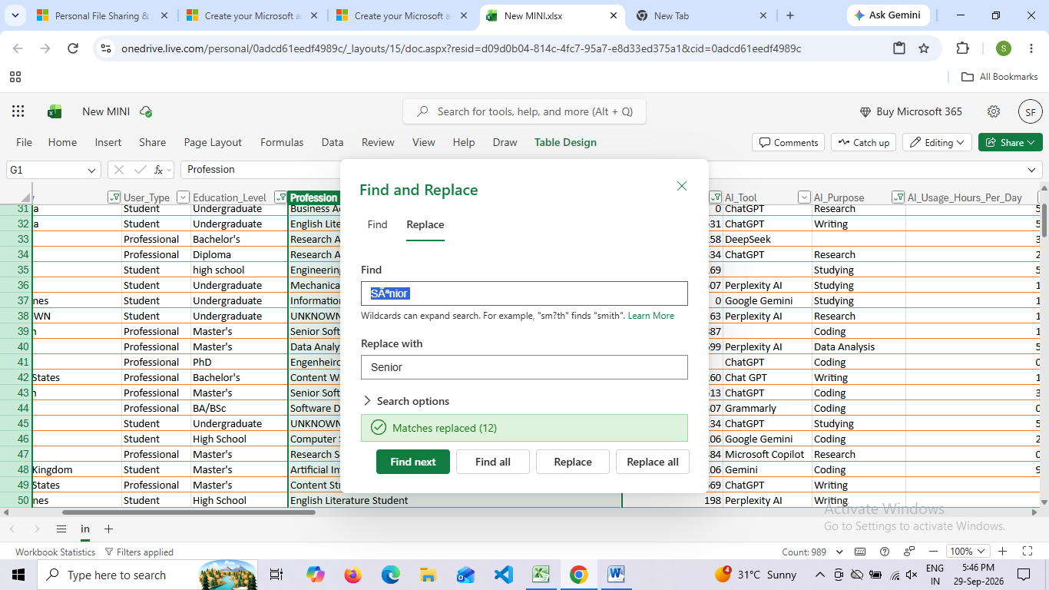
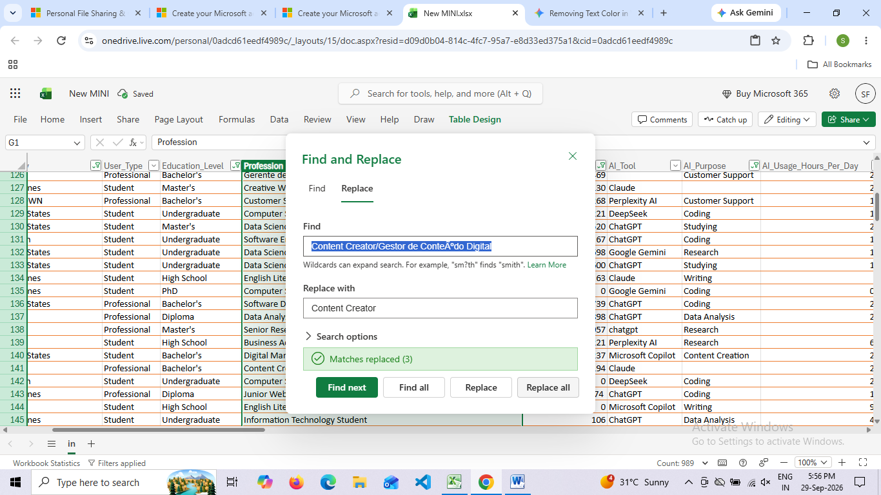

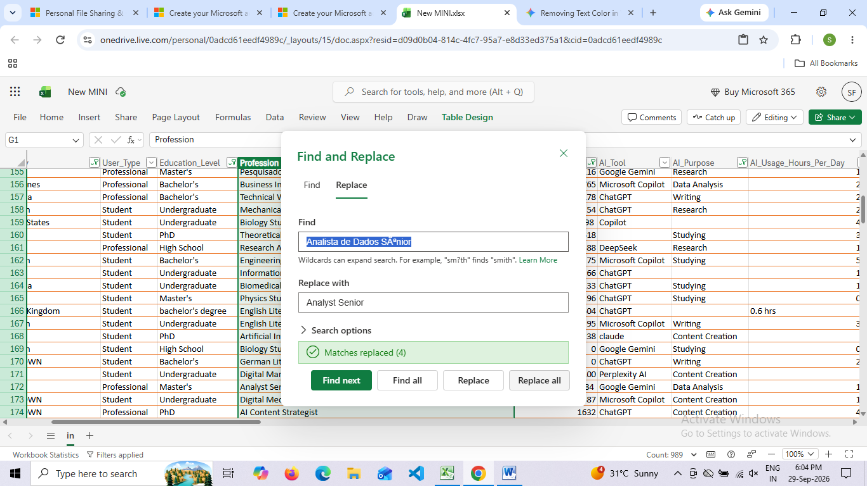
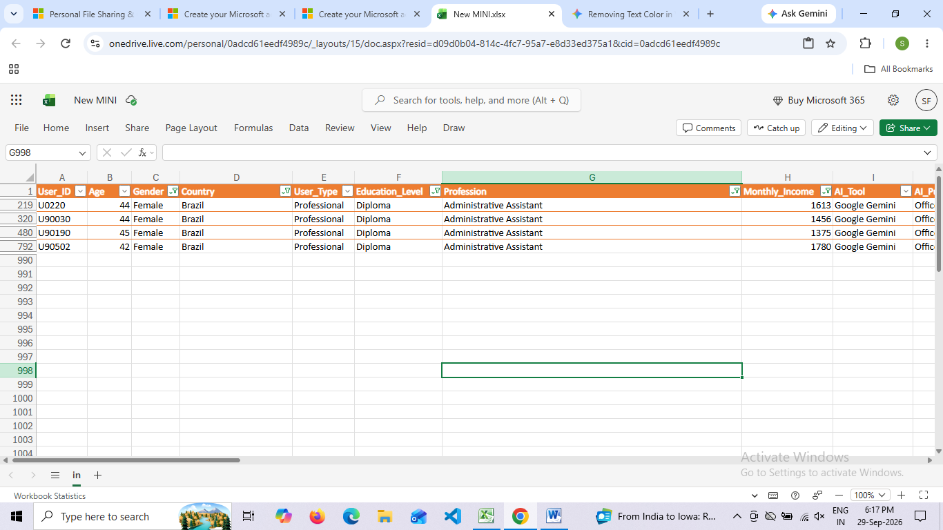
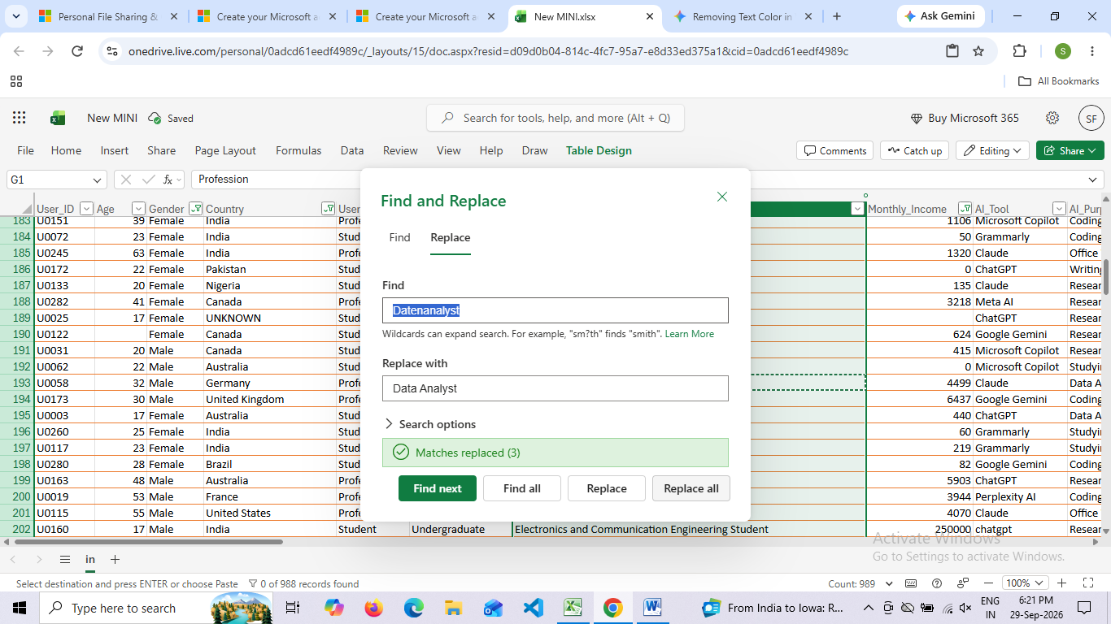

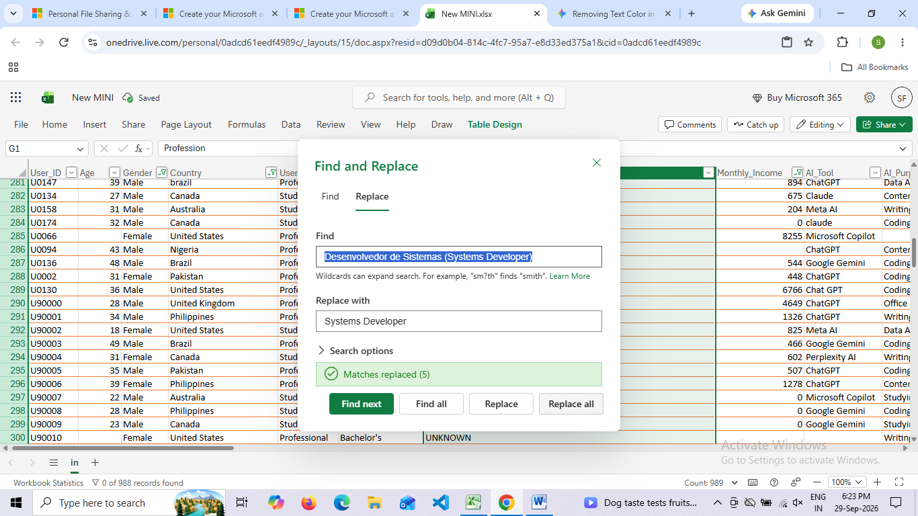
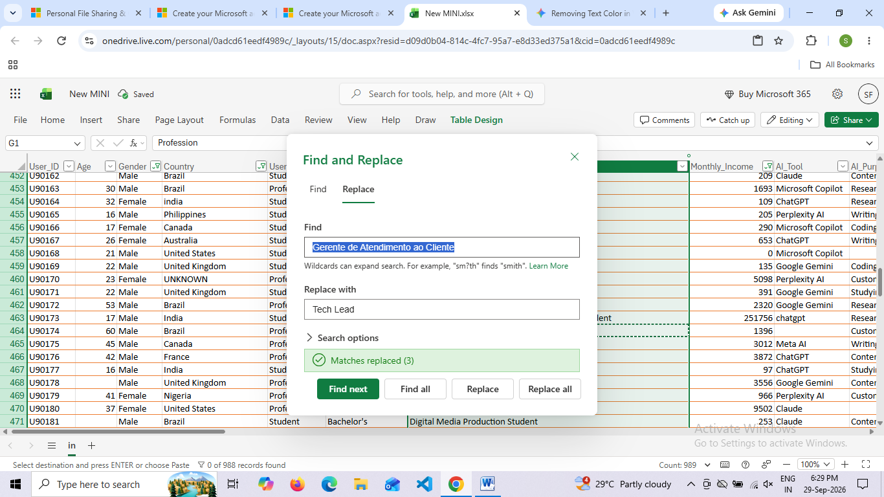
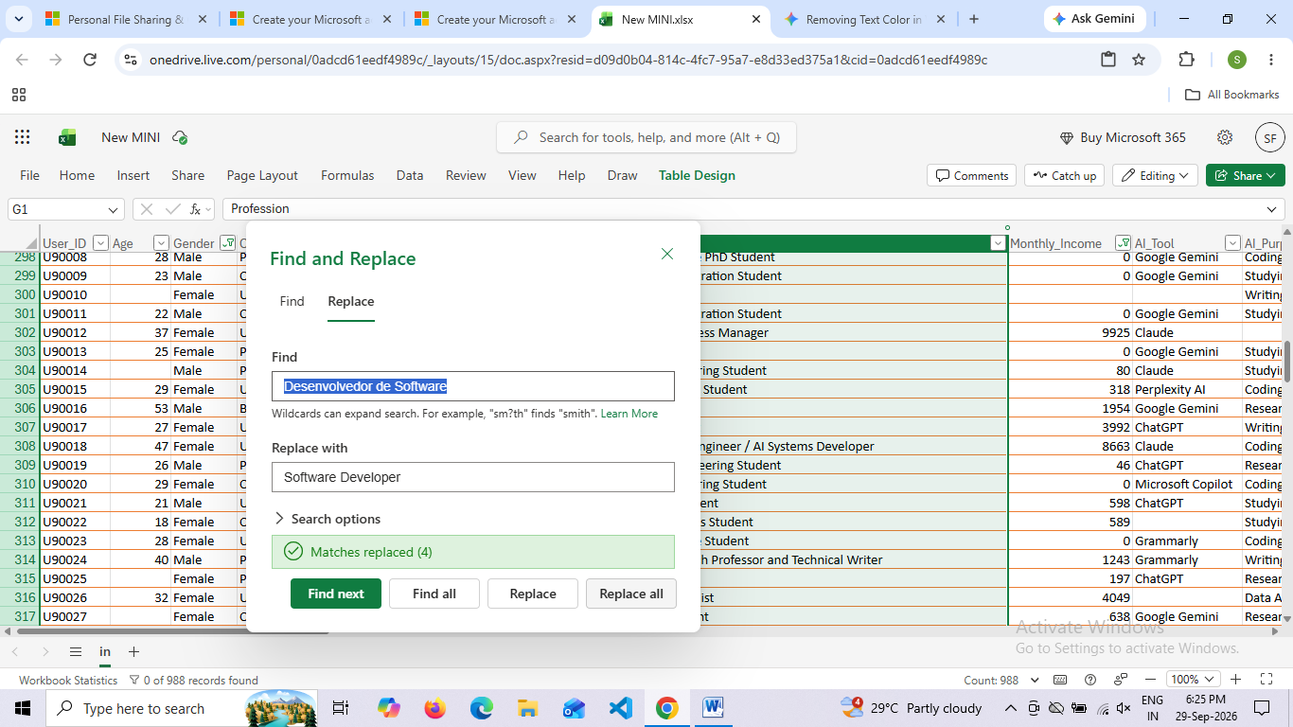
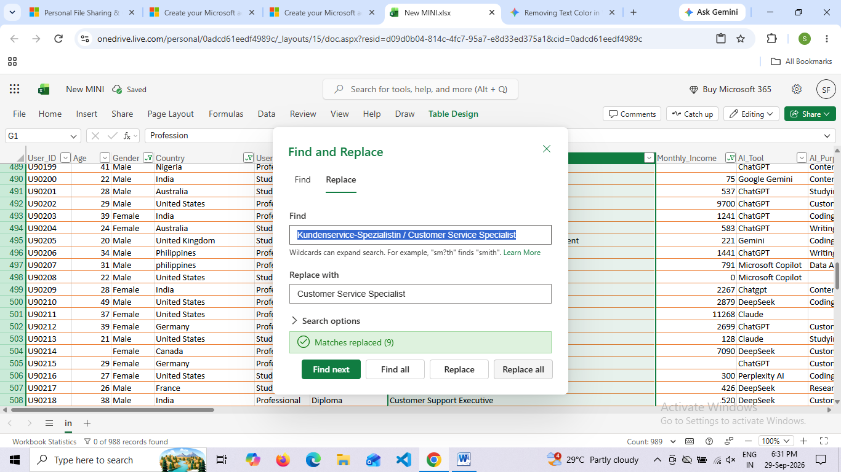
- Profession may contain extra space use TRIM
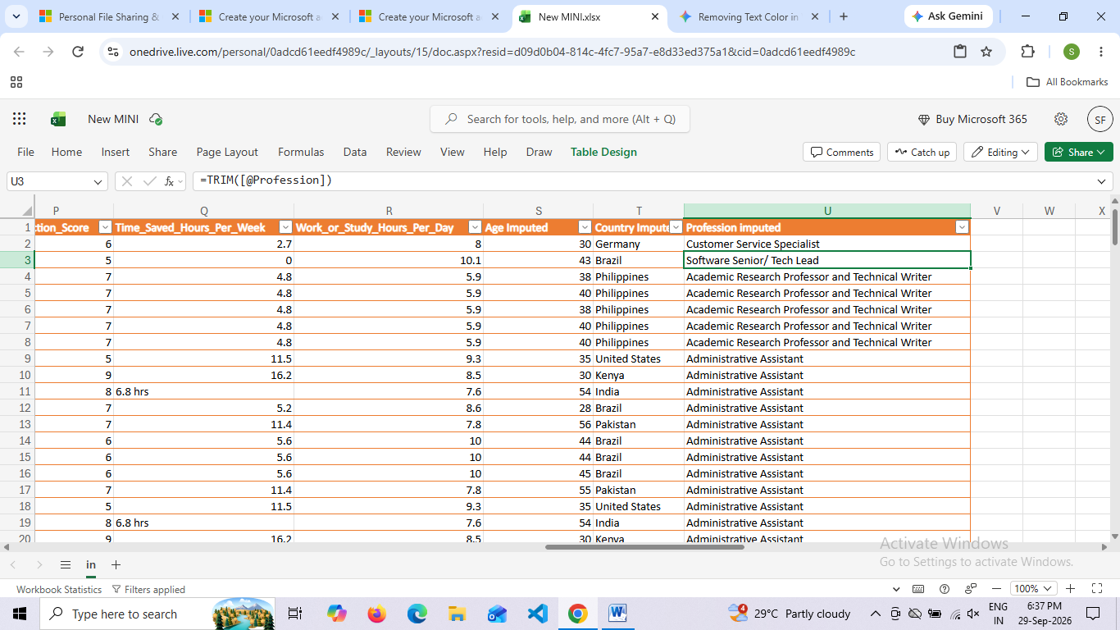

MONTHLY_INCOME
Monthly income imputed by using if and AverageIF
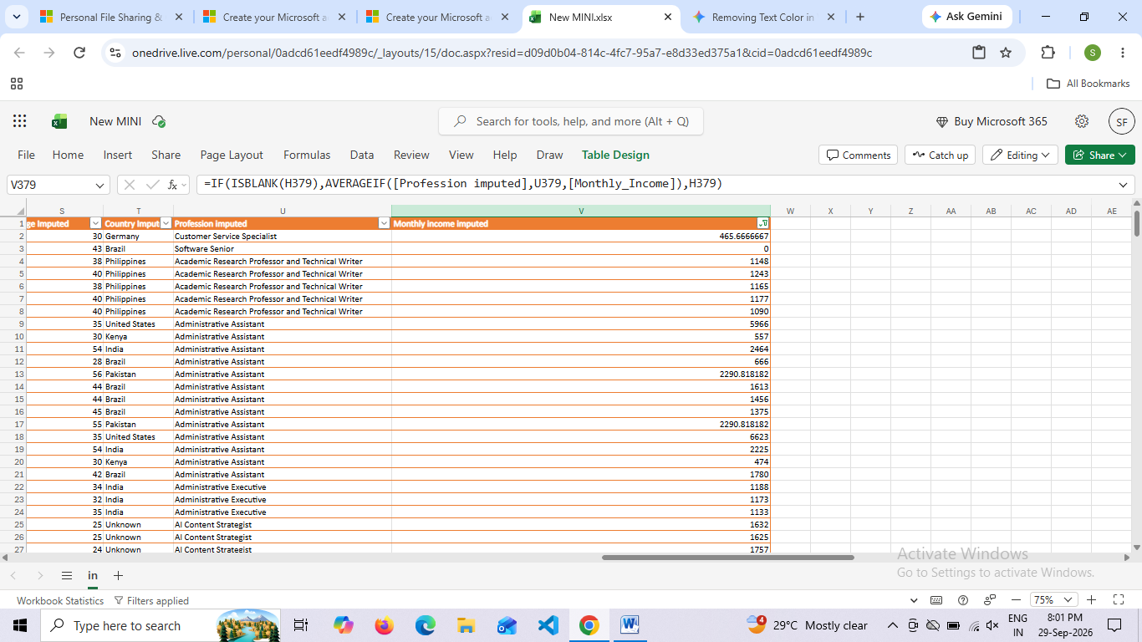
- Data type is converted to currency
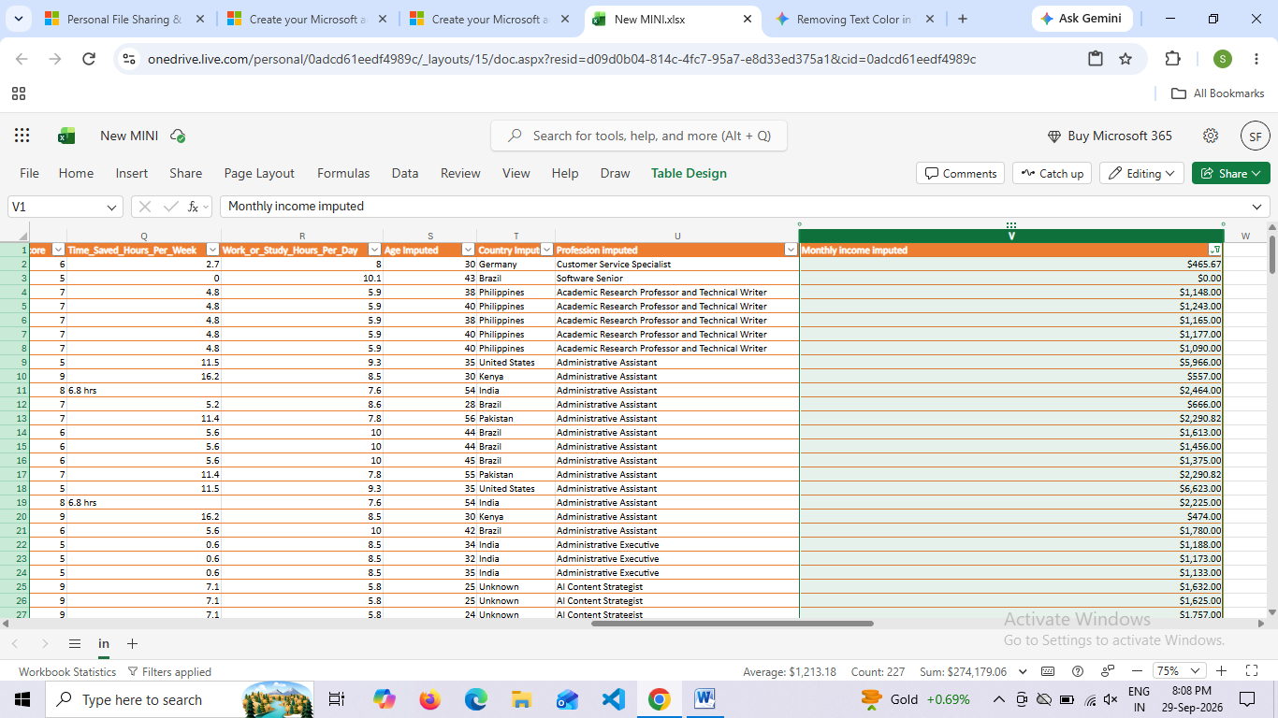

AL_TOOL
- Missing cells in AI_Tool is imputed by using Unknown
- Use Proper Function

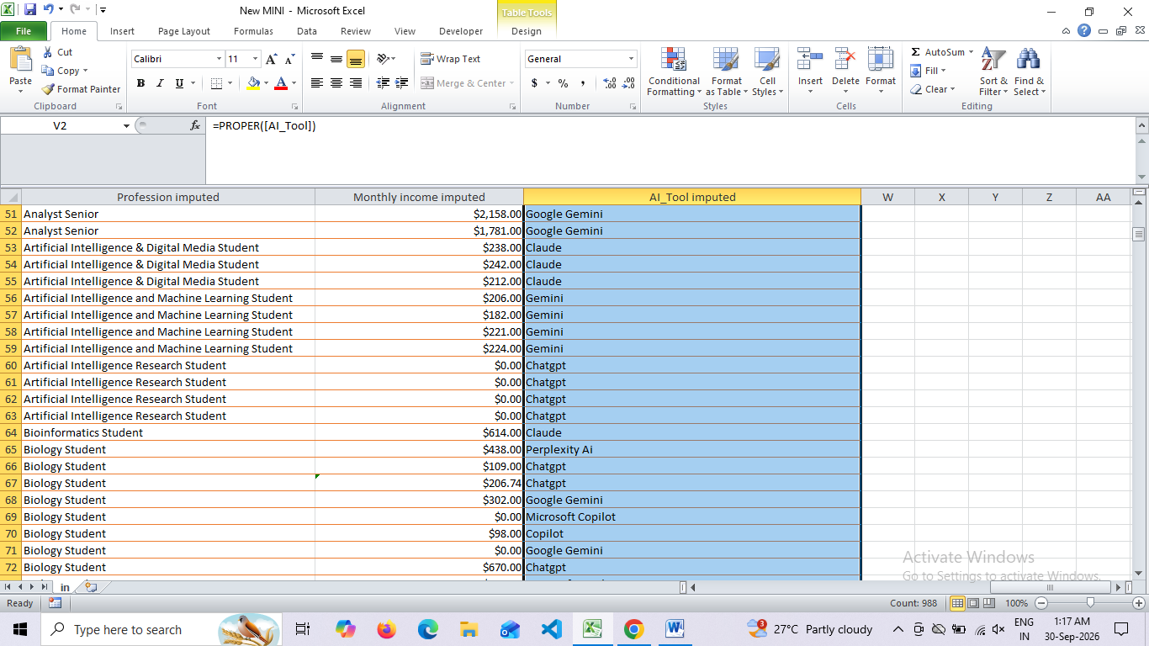

- Inconcistancy in Chat Gpt
- Gemini
- =PROPER(TRIM([AI_Tool]))
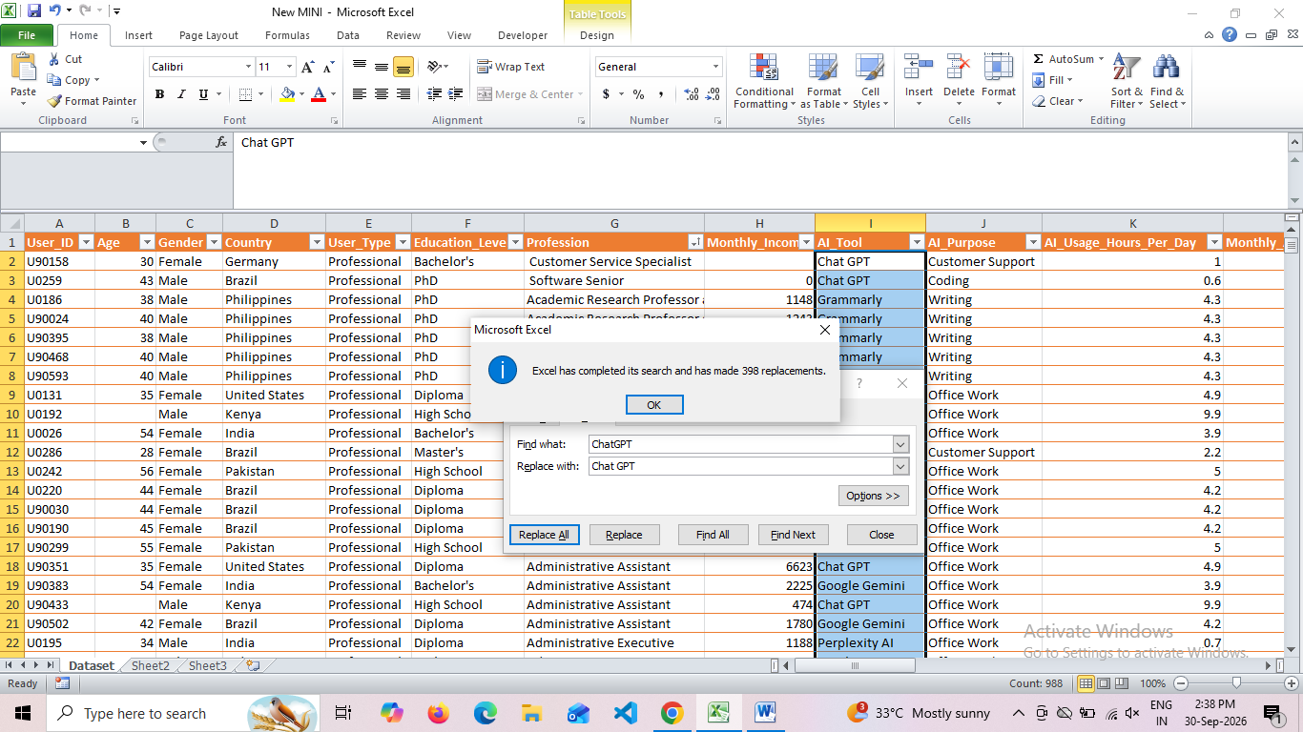

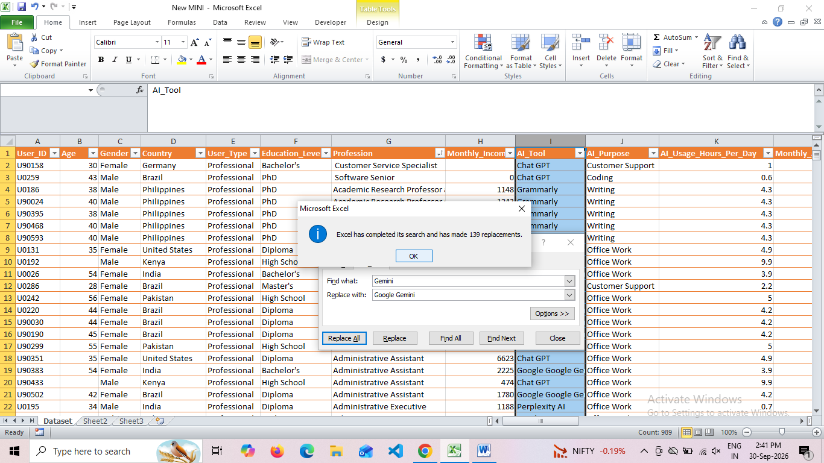

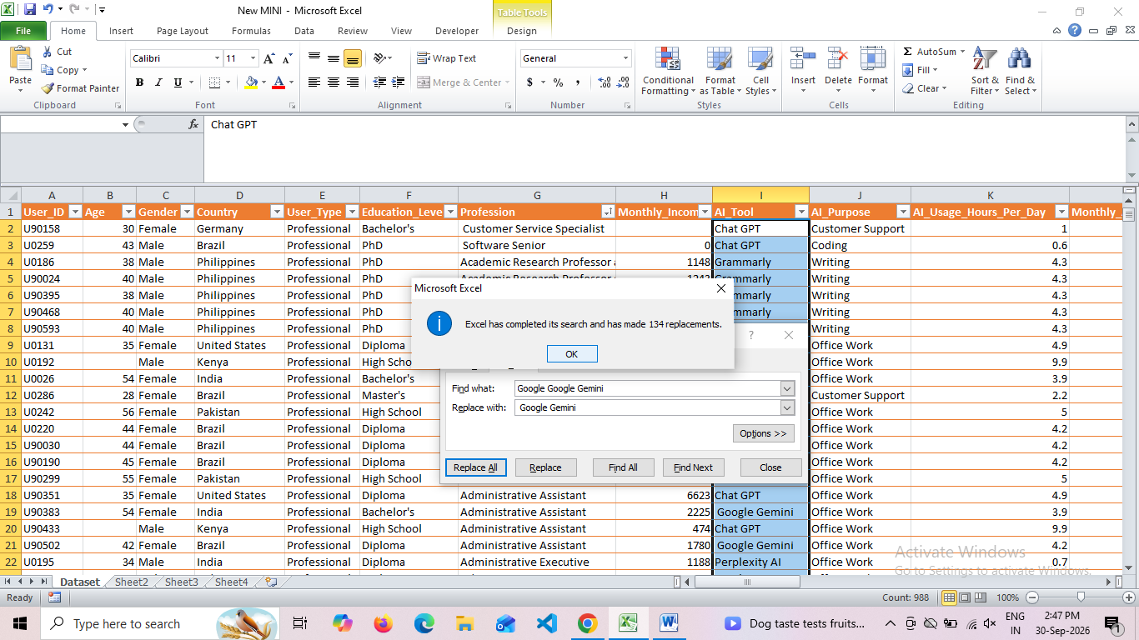
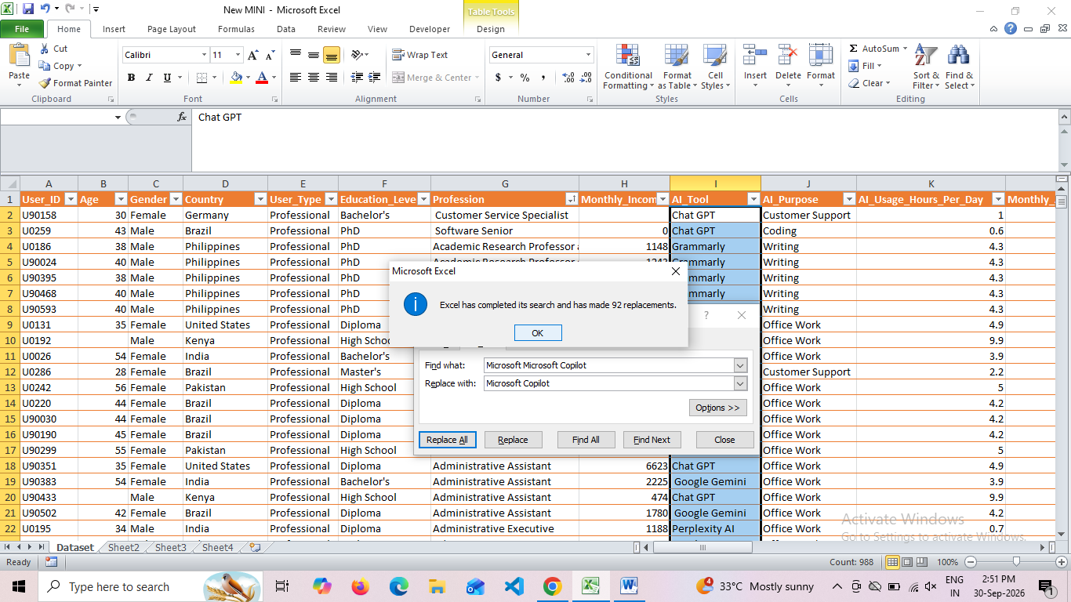

AI_Usage_Hours_Per_Day
- Typo error hrs contain
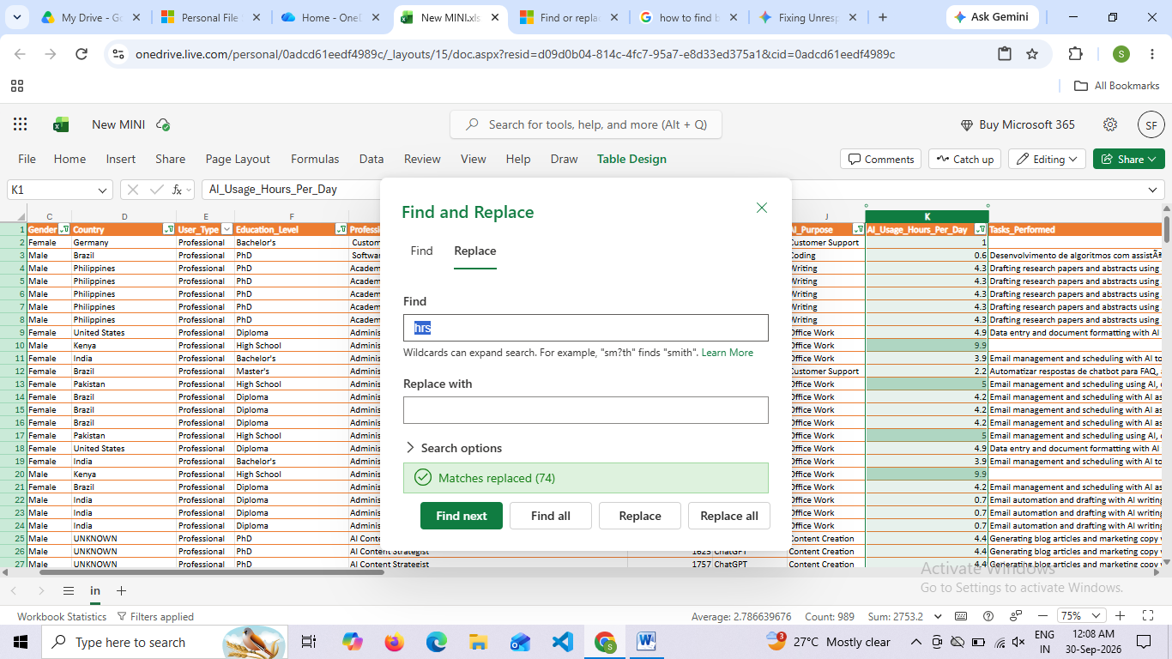
Monthly_AI_Cost
- DataType error is present
- 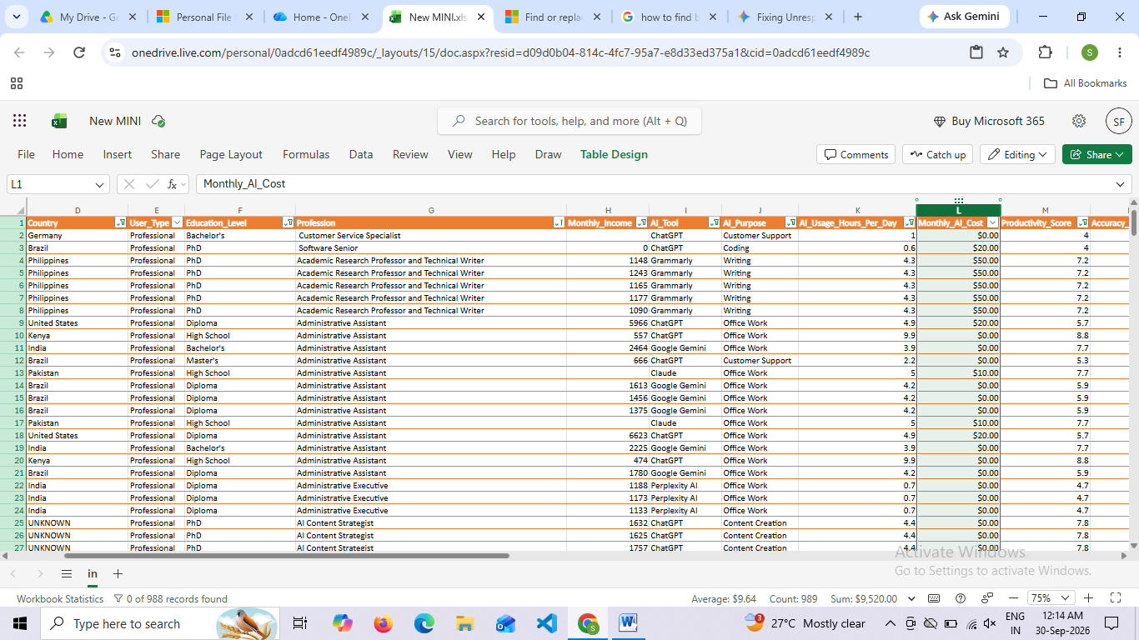

AI_PURPOSE
The Missing value Find out by using go to special then find out blanks analyze with profession then cell is imputed
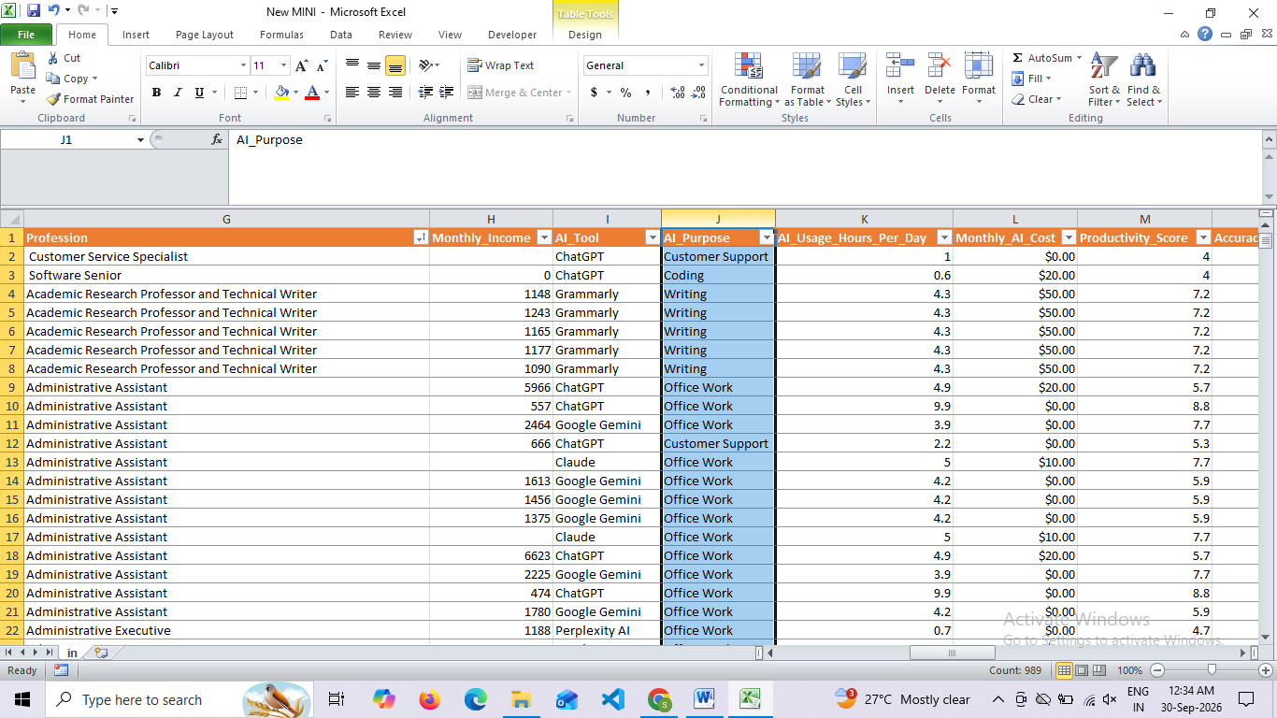

Productivity_Score
- In Productivity ScoreMissing Values Replace with 0
- Datatype is converted to number
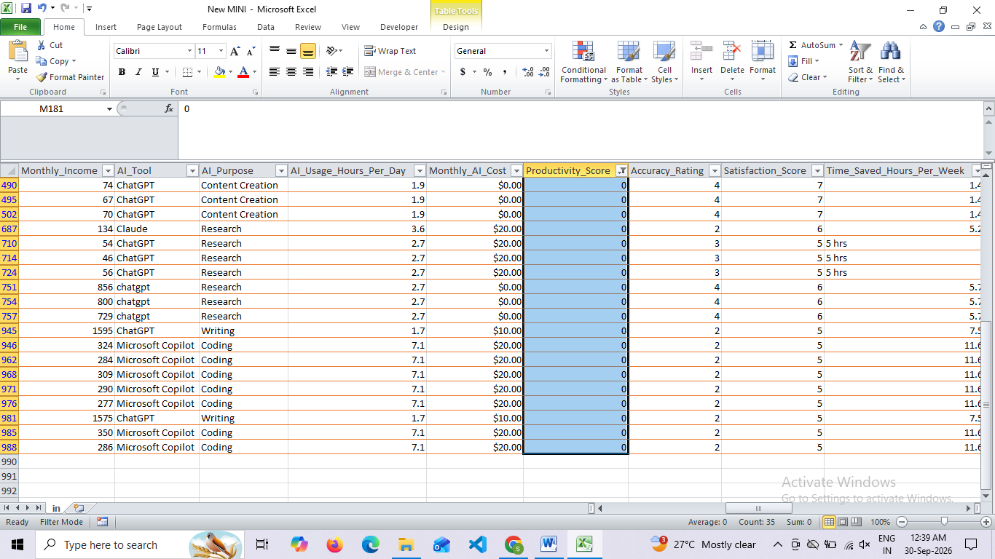
Satisfaction_Score
- The Missing Value Is Imputed by using NestedIf
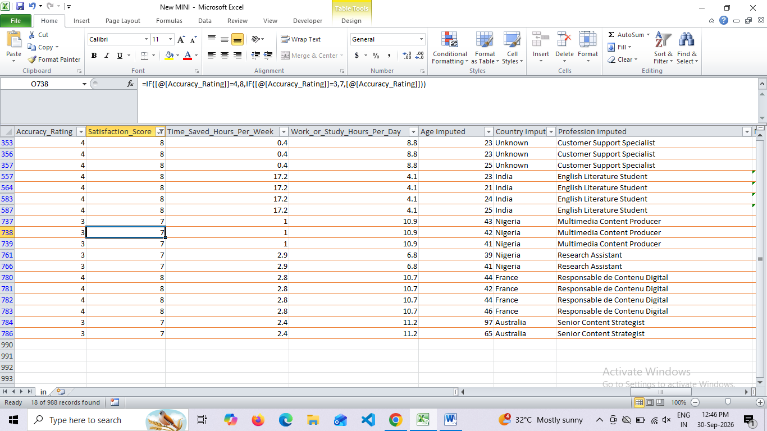
Time_Saved_Hours_Per_Week
- Datatype is converyed to number
- Inconsistent data contain
Eg :hrs
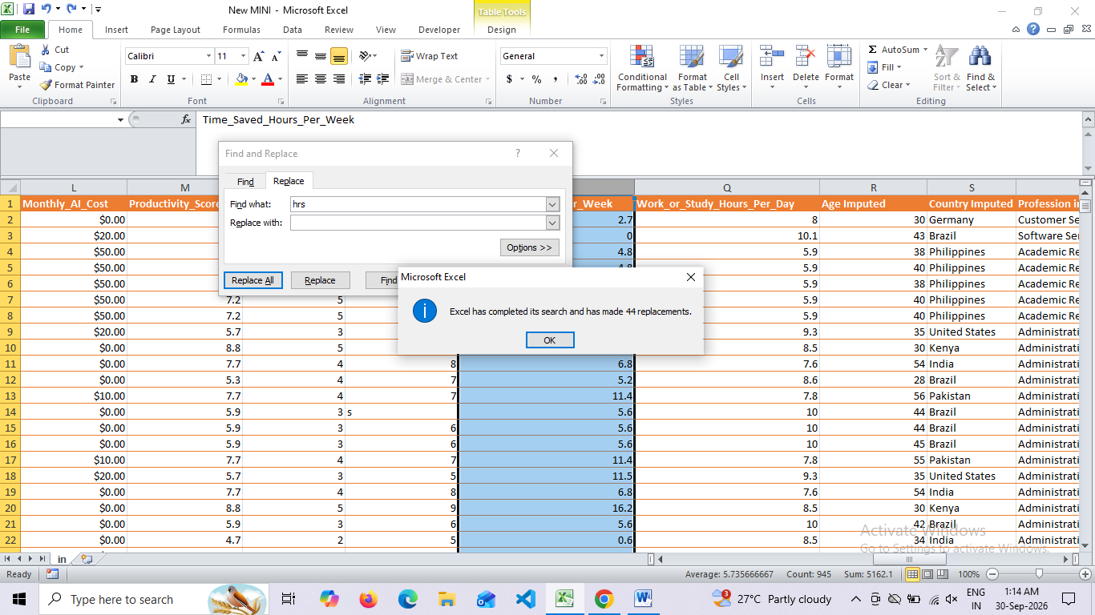

- Missing Values are imputed by using AVERGEIF based on Satisfaction_rate

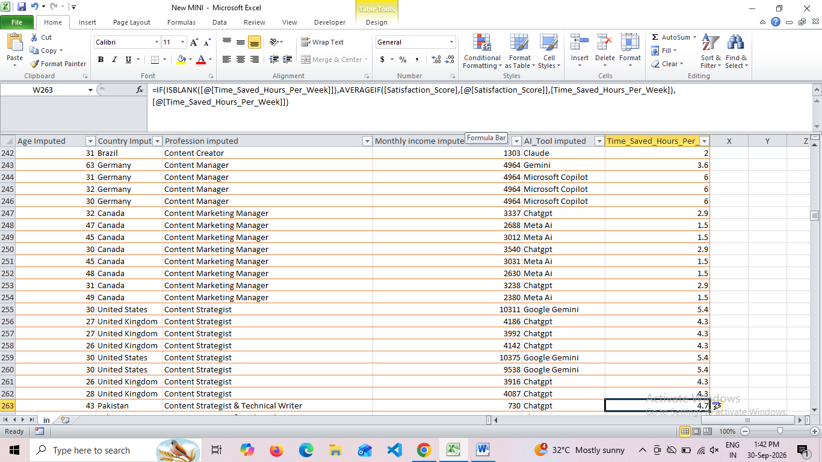
- Convert Datatpye to Number also correct decimal values
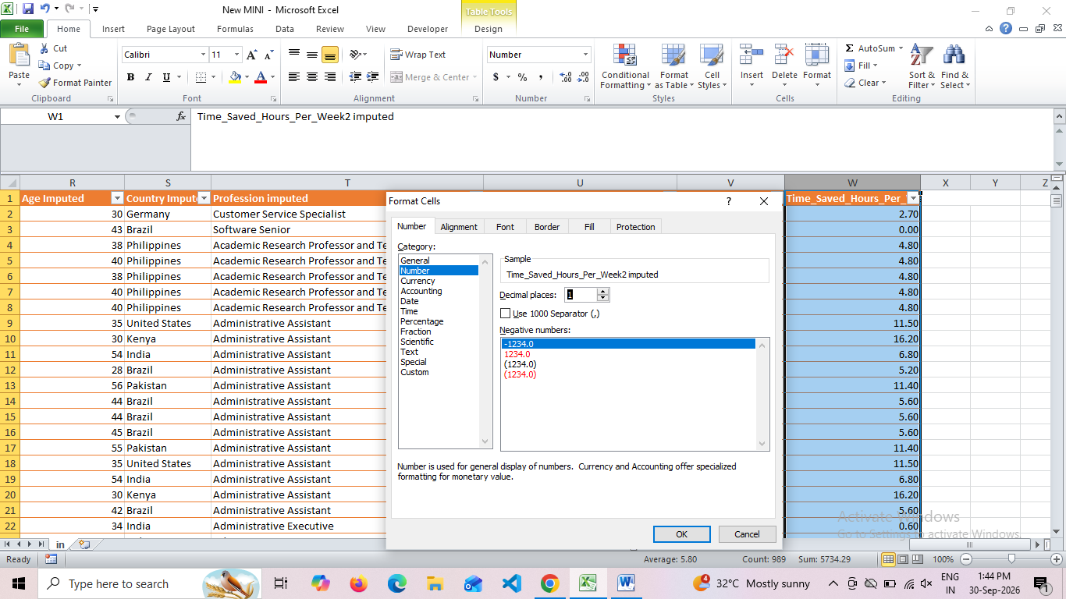

Work_or_Study_Hours_Per_Day
- Inconsistant Data “hrs “contain
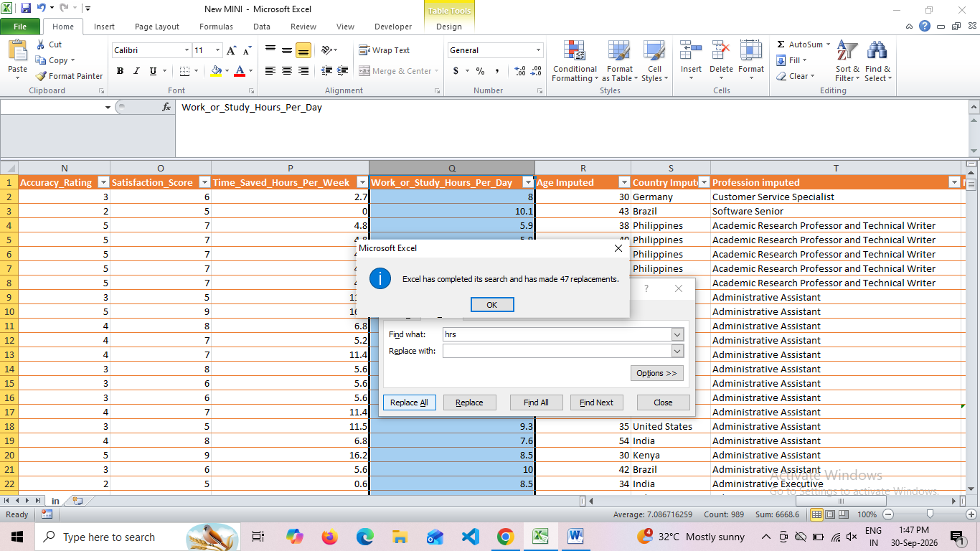

Monthly Income imputed
- Amount sorted
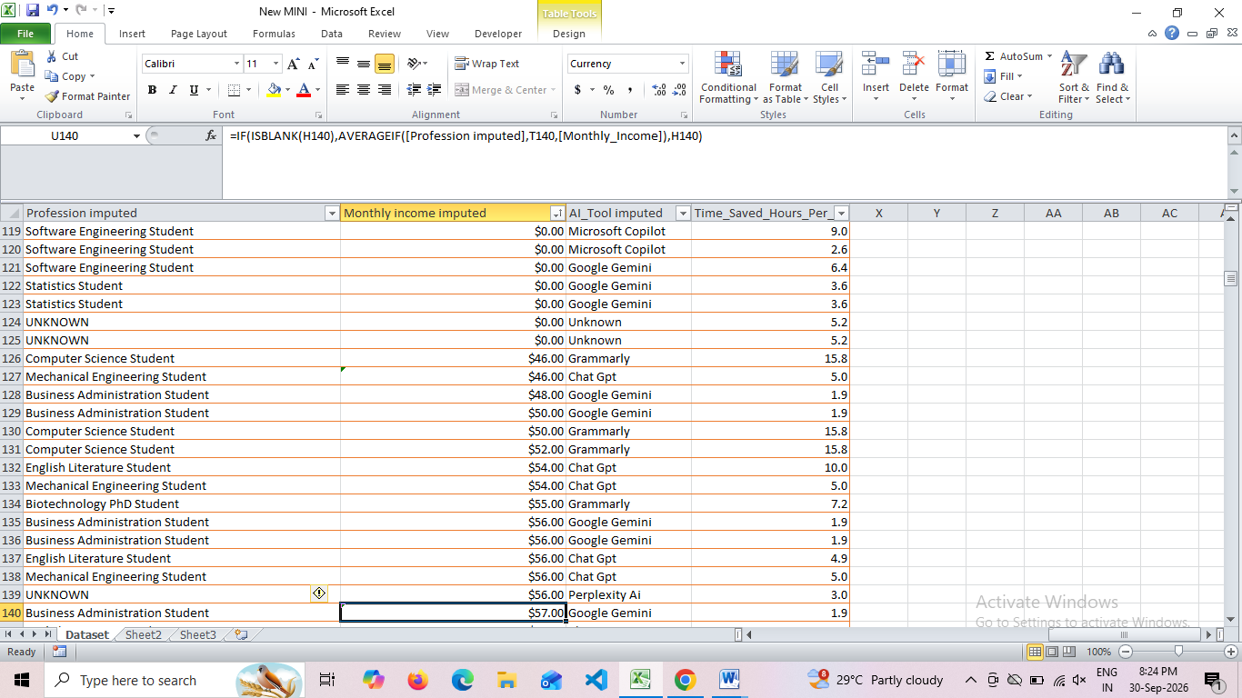
PIVOT TABLES
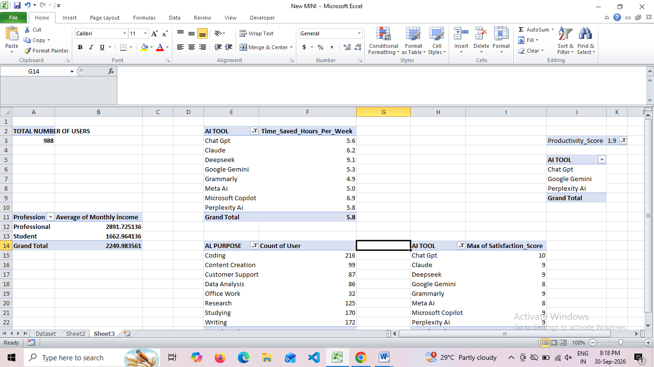

Data Visualization

DAX Measures
- Average AI Usage
- Total Mothly Cost
- Total Proffesional
- Total Students
- Total Users

DASHBOARD

Cards
- Total Users (988): Represents the complete operational sample size tracked in the underlying dataset.
- Total Monthly Cost ($9.52K): The collective financial investment allocated across all monitored AI platforms.
- Average AI Usage (2.79 Hours/Day): The mean time spent utilizing artificial intelligence tools per individual per day.
- Total Professional (472 Users): Count of workforce-employed professionals actively operating within the dataset.
- Total Students (516 Users): Count of academic student accounts captured in the study.

- Average of Productivity (5.04 / 10.00):
The normalized baseline productivity improvement rating calculated across all systems.

Slicers
Allows dynamic row-level filtering of the data based on user demography. End-users can dissect the charts instantly by selecting specific values for AI_Purpose, Country, Education_Level, User_Type, and Gender.

AI Tool Adoption Of Users
- Clustered Column Chart.
Ranks the volume of users active on each platform.
- Key Finding: Chat GPT dominates market penetration with 411 users, followed by Google Gemini (139 users), Microsoft Copilot (104 users), Claude (97 users), and Perplexity AI (85 users)
Monthly AI Cost Analysis
- Funnel Chart.
- Functional Purpose: Illustrates financial expenditure concentration down the stack relative to the maximum tier baseline (100%).

Productivity Score and Satisfaction Score
Side-by-Side Dual Column Chart.
- It aligns calculated user satisfaction scores simultaneously alongside standard task productivity gains across categorized software platforms like Unknown tools, Meta AI, Microsoft Copilot, Grammarly, and Perplexity AI.

Monthly Income by AI Tool Allocation
- Donut Chart.
- Examines the demographic division of economic value.
Purpose and Users Distribution
- Treemap visual container.
- Maps volume distribution across core focus tasks.
AI Usage and Time Save (Scatter Plot)
- This chart analyzes the correlation between how much time users spend using AI tools per day versus how many hours they save per week

Accuracy Rating ( Bar Chart)
- This chart compares and ranks the different AI platforms based on their perceived or calculated accuracy scores

Findings
- Chat GPT dominates market penetration with 411 users, followed by Google Gemini (139 users), Microsoft Copilot (104 users), Claude (97 users), and Perplexity AI (85 users).
- Chat GPT represents the largest absolute expenditure category, while Google Gemini is situated at 27.66% of that baseline cost scale, followed closely by Microsoft Copilot at a compressed 10.9% segment level.
- The visualization demonstrates that Student users make up 56.19% of the utilization focus, while Professional users occupy 43.81%
- Coding (216 users) represents the largest operational workflow application, followed sequentially by Writing (172 users), Studying (170 users), Research (125 users), Content Creation (99 users), Customer Support (87 users), and Data Analysis (86 users).
- Chat GPT is the clear winner here, with its blue bar stretching all the way across the screen, dominating the accuracy rating.
Conclusion
This mini-project delivers an interactive Power BI analytics dashboard that evaluates the adoption trends, financial costs, and operational impacts of artificial intelligence tools across a diverse sample of user data. The data reveals a clear market concentration, with Chat GPT emerging as the primary platform of choice and software programming (Coding: 216 users) serving as the leading functional application across a balanced demographic split of 516 students and 472 professionals. By converting complex behavioral metrics into clean, high-level KPIs and data cross-filters, the system provides a production-ready blueprint for analyzing software utilization and optimizing enterprise resource investments.

